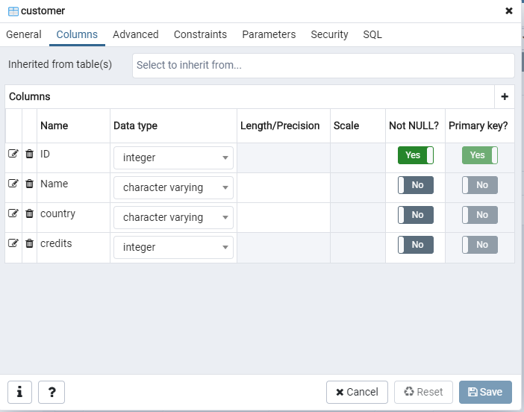

INSERT INTO public.customer(

"ID", "Name", country, credits)

VALUES (11, 'Anne Harris', 'USA', 158368);

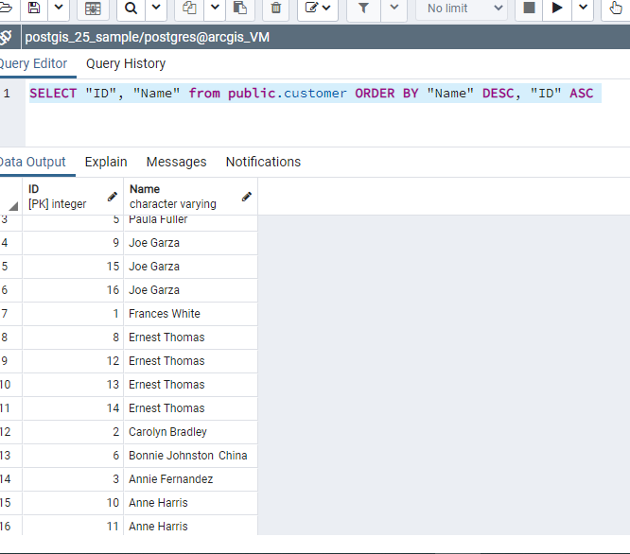

select id, name, marks,

CASE

WHEN marks > 90 then 'A+'

WHEN marks > 70 then 'A'

WHEN marks > 50 then 'B'

WHEN marks >= 40 then 'C'

ELSE 'Fail'

END AS Grade_details

FROM public.student

ORDER BY id;

